# Weekly Journal

## Week5 Reflection + design interview / survey questions

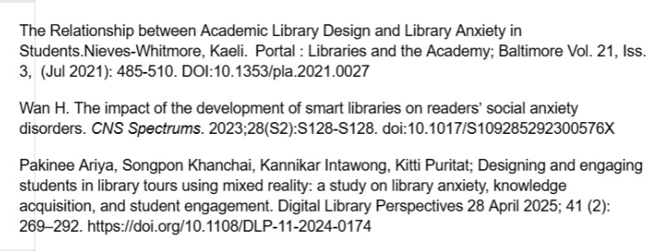

文本, 信件

AI 生成的内容可能不正确。图形用户界面, 文本, 应用程序, 信件

AI 生成的内容可能不正确。

文本, 应用程序, 信件

AI 生成的内容可能不正确。图形用户界面, 文本, 应用程序, 电子邮件

AI 生成的内容可能不正确。

图形用户界面, 应用程序, Teams

AI 生成的内容可能不正确。图形用户界面, 文本, 应用程序, 电子邮件, Teams

AI 生成的内容可能不正确。

文本, 信件

AI 生成的内容可能不正确。

# Week 6 Got survey & Interview data+Analyzed

文本

AI 生成的内容可能不正确。图片包含 表格

AI 生成的内容可能不正确。表格

AI 生成的内容可能不正确。表格

AI 生成的内容可能不正确。

# Week 7

图形用户界面, 应用程序, Teams

AI 生成的内容可能不正确。

文本

AI 生成的内容可能不正确。

文本, 信件

AI 生成的内容可能不正确。

# Week 8 Analyzed 4 interview transcripts & all survey responses data and Design Low fidelity prototype

表格

AI 生成的内容可能不正确。

表格

AI 生成的内容可能不正确。文本

AI 生成的内容可能不正确。

表格

AI 生成的内容可能不正确。

表格

AI 生成的内容可能不正确。

# Summary

## TA Summary

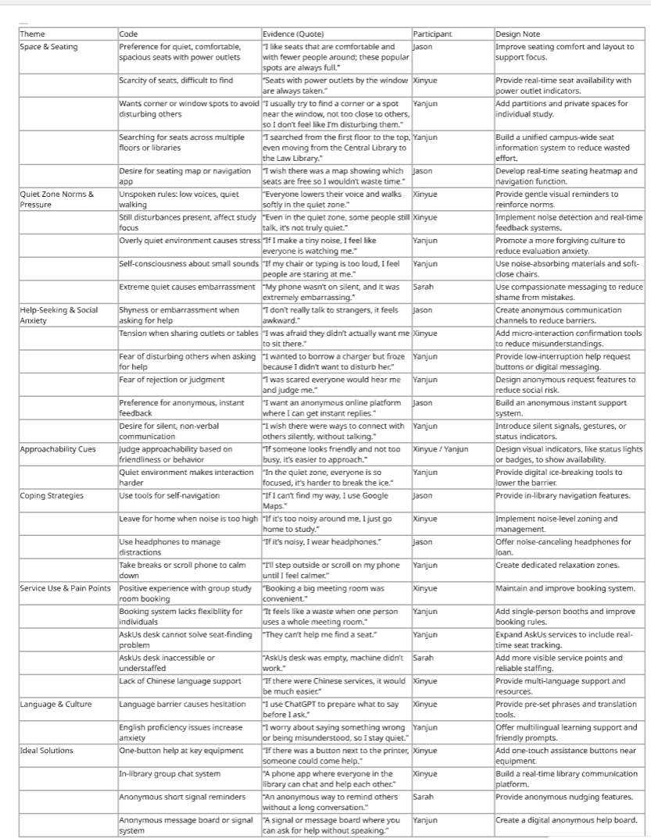

### Conducted four interviews and identified **three main themes**.

Theme 1: Seat and Space Conflicts

Key Findings

Students prefer quiet, comfortable seats with power outlets, but these seats are extremely limited.

They often have to search across multiple floors or even different libraries, wasting time and energy.

Design Implications

Develop real-time seat availability maps and noise-level heatmaps.

Introduce small, bookable personal booths to reduce competition for popular seats.

**Theme 2: Quiet Zone Rules and Social Anxiety**

**Key Findings**

In quiet zones, unspoken norms like whispering and soft walking are widely followed.

However, **extreme silence causes stress, leading to self-monitoring and fear of judgment.**

Asking for help in this environment is **highly stressful**. Students prefer **anonymous, low-friction digital channels** such as buttons, short signals, or group chats.

**Design Implications**

Create **anonymous micro-interactions** and **digital communication systems** to replace face-to-face requests, reducing social pressure.

**Theme 3: Service Support Gaps**

**Key Findings**

International students face **extra barriers** due to language and cultural differences.

Many use tools like **ChatGPT** to prepare what to say before interacting with staff.

**Current services, such as AskUs, cannot solve practical issues like finding seats** and lack multilingual support.

**Design Implications**

Provide **multi-language interfaces** and **intuitive service points**.

Offer **digital tools for silent or non-verbal communication**, making it easier for international students to ask for help.

**Overall Design Recommendations**

**Reduce seat-hunting stress**: Build visualization tools for seat availability.

**Lower social pressure**: Offer anonymous, low-barrier communication options like silent signals or anonymous requests.

**Real-time help**: Add one-button help features linked to mobile chat systems.

**Foster an inclusive culture**: Use gentle messages and visual cues to promote tolerance and inclusivity in quiet zones.

**Support international students**: Improve multilingual support to make libraries more accessible.

## Questionnaire- verify+analysis

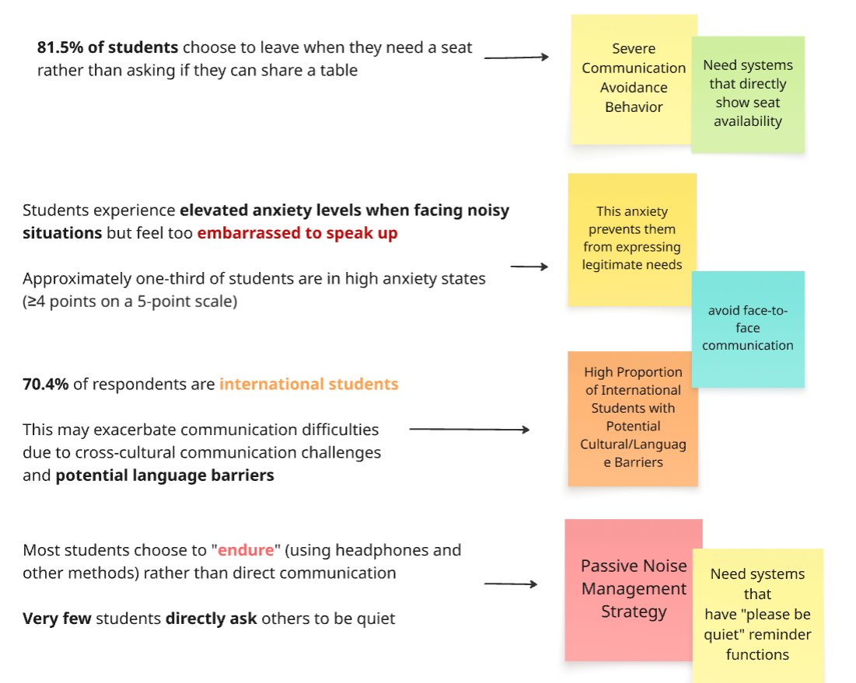

## Common Problems：

*1.Social Anxiety in Library Environments 、 2.Communication Avoidance and Fear、*

*3.****Difficulty Seeking Help***

4.International Student Challenges

5.Need for Non-Verbal Communication Solutions

## Pain point + persona RH

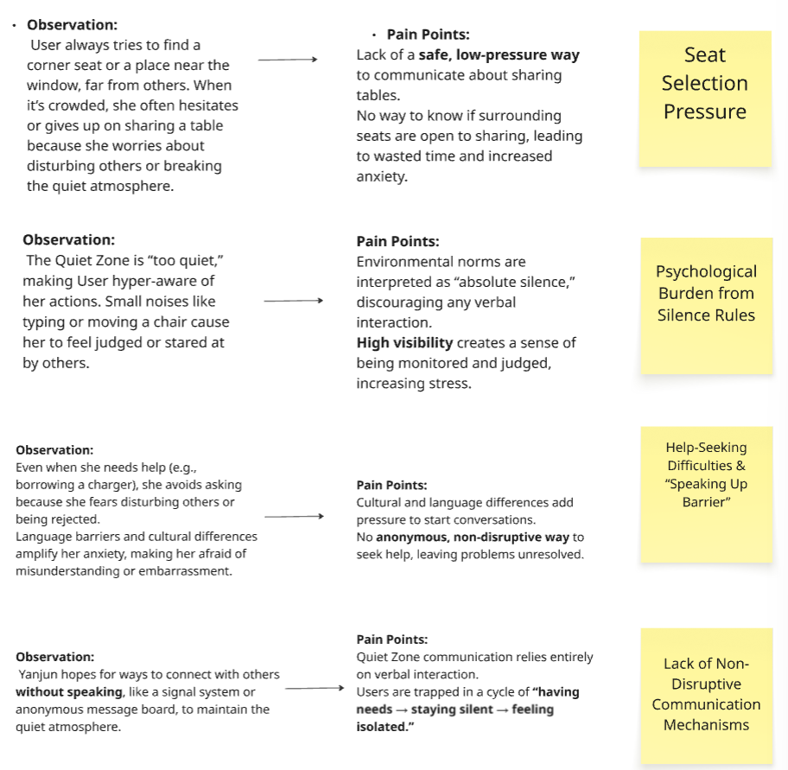

## Core Psychological Model:

* *Environmental rules + high visibility* → **behavioral inhibition**
* *Cultural/language differences* → **self-doubt**
* → Leading to **speaking-up barriers** and **social withdrawal**

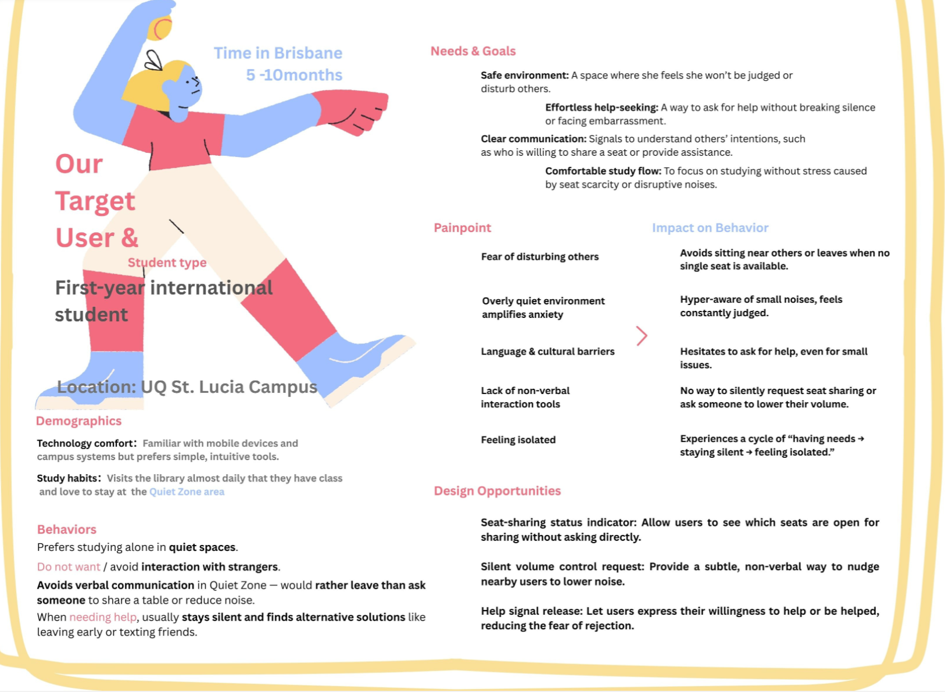

## Opportunities

日程表

AI 生成的内容可能不正确。

## Interaction Flow XY

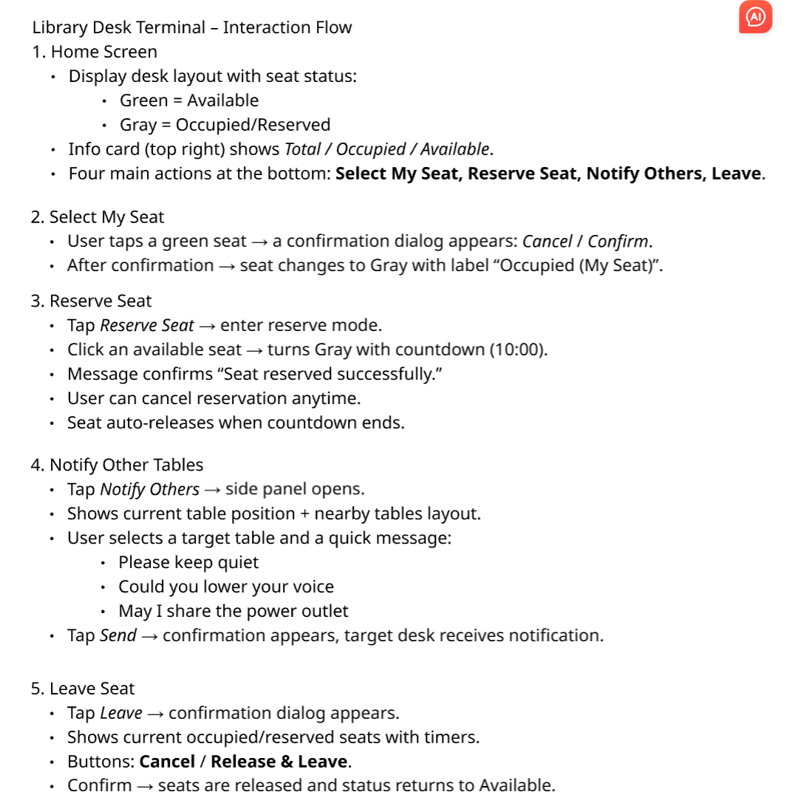图形用户界面

AI 生成的内容可能不正确。图形用户界面, 应用程序

AI 生成的内容可能不正确。图形用户界面, 应用程序

AI 生成的内容可能不正确。图形用户界面

AI 生成的内容可能不正确。图形用户界面

AI 生成的内容可能不正确。图形用户界面, 应用程序

AI 生成的内容可能不正确。